**Lesson 10**

* Today’s lesson activities will be done autonomously while I call you to do the speaking practice with me.
* Please, use vocabulary from unit 10 in your book and try to relative clauses when possible.
* Do the activities on this document and upload it on POLIFORMAT – TAREAS.
* Deadline: During today’s class time

**Practice 10 – Psychology**

**Part 1 –Listening**

**Go to PoliformaT – Tests and quizzes / Examenes**

**Open the task L1G1 / L2G2 – Practice 10. In total you will have 13 minutes to finish it, so don’t waste time. Remember you can hear the recordings just twice.**

Record a **2-MINUTE FLIPGRID** in which you answer these questions:

* **According to the speaker, how has the concept of friendship changed over the years?** (mention as many examples given in the recording as possible)
* **What do you think about making friends online?**

I’ll stop you after 2 minutes.

**Speaking Topic 9**

**PART 1. Watch this video in your chat room and answer the questions:**

* How social media affects your brain

<https://www.youtube.com/watch?v=rzUb_GeLDg8&ab_channel=BuzzFeedVideo>

* What did the experiment in which different groups saw the same photo with more or fewer likes prove?
* Why do we feel satisfied when we receive likes?
* What is the phantom vibration syndrome?
* Have you ever experienced any of the situations discussed on the video?

**PART 2. Discuss these questions (you don’t need to discuss all of them, but try to discuss a few giving reasons for your opinions):**

* Do online friends count as real friends?
* Should companies ban their employees from using social networking sites at work?
* Would you add your boss / teacher to your social media? Why / why not?
* Do you think it is easy to compare yourself to others on social media? Why?
* What are the pros and cons of social networking?
* Are you better at networking (*establishing connections with other people*) face to face or online?
* Is it possible that social networking sites make people lonelier?
* Are social networking sites changing our behaviour?
* Do you or people you know seek validation on social media?
* How is your behaviour different in face-to-face lessons and online lessons?
* Do you think users should be taught how social media work before they use them?
* Why do you think people take this type of photos? Why do you think they are successful?

  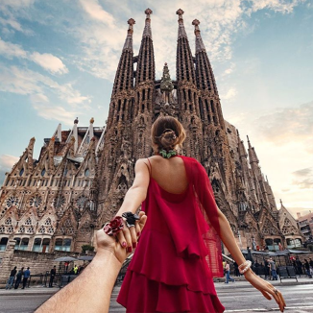

Record a **5-minute** video in which you explain how social media affect us and you give your opinion on whether using them is mostly beneficial or not.